Software Design Document

for

Meezy Cutz

Kierra McCallum
Zack Munford
Ayman Ibrahim

- INTRODUCTION
The sole purpose of the software design document is to give a description of the Meezy Cutz appointment booking system. Topics included are:
- Class diagram
- User interface design
- Method/Operation specification
- Interaction diagrams
- Database design
- Test cases
All in all, this document should leave the reader with a clear understanding of how the use of the online appointment system works.

NEEDS TO BE CHANGED
- SYSTEM DESIGN DESCRIPTION OVERVIEW
This project is being designed using an incremental approach. There are three primary stages to the design development which culminate in Release 1, due September 28, 2000; Release 2, due the week of October 9, 2000; and Release 3, due the week of October 30, 2000. The Beta Release will be delivered to the customer for testing the week of November 13, 2000. The final product will be delivered to the customer the week of December 11, 2000.

The CBASS system is a layer on top of the Unix environment, which controls its application and resource usage. Typical flow through the system is diagramed below:

User
Client

Client
CBass
2. Get Credential
3. Request Resource
User
CBass
Local Machine
Remote Machine

1. Get Template

Server
CBass

Server

Figure 1. Flow diagram of resource and credential passing through the system.

Once the initial interfaces and networking connections are established, the mechanisms needed to pass certificates and actually authorize or deny access to a resource based on the user's authentication in the system will be supplied. To request a resource, the client gets a template from the server. Templates are used to describe a valid certificate, dynamically. Templates allow the user to search the database and find the appropriate certificate for the resource.

Figure 2 below shows a more detailed relationship of objects in the CBASS environment, and the actions performed.

Requester
CM
Responder
Request
Yes/No
Request
Add/delete/list
Response
CBass

CI
CD

Yes/No
Request

CV

Figure 2. Integration of objects and their actions in the CBASS system

The user interface will run on the Unix environment, specifically Solaris 5.7, running Java 1.2, with graphical Java interface capabilities.

The network communication used for SeaBASS is Remote Method Invocation (RMI). This is a built in functionality of Java, using TCP/IP protocols. It provides the ability to call remote methods on other machines.

SeaBASS consists of several components: CBass, CI, CM, CV and CD. These components are described in section 5.0 Module Descriptions.

There are two types of external applications: Requester and Responder. Any external application that instantiates a CBass object has the ability to request a resource. An external application that instantiates a CBass object and implements the CbassInterface has the ability to respond to resource requests. Cbass uses the getResource implemented from the CbassInterface to call the Responder. This provides a common interface for all Responder applications.

When Sea BASS is run with a graphical user interface, it will display on screen with a text field for the user to log into, and an area for the user to request the resource application desired. A “login” button will be provided to execute the authentication process. Figure 3 shows a view of the Machine login window.

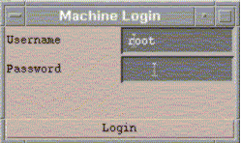
Figure 3. Machine Login window.

When a successful login the User object will start and its display will be view on the screen as shown in Figure 4.

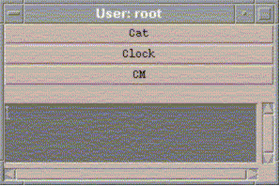
Figure 4. The User window.

Buttons of the available SeaBASS applications are displayed in the User window. A text field will display any error messages that may arise during execution.

A variety of small applications, including a file server, will be developed to use in the Sea BASS system. Figure 5 shows an example of a successfully requested file.
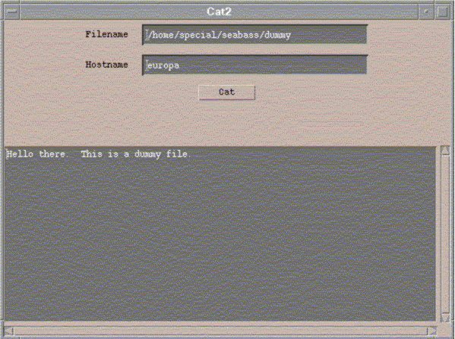
Figure 5. The Cat application requests a "dummy" file, which is viewed in the window upon successful authorization of the request.

If a request cannot be authorized, the Cat application displays a message received from the system that authorization failed.

SeaBASS also allows the administrator to add, delete, and list policies and certificates via a GUI interface. Figure 6 shows the Certificate Manager (CM) which facilitates these editing capabilities.

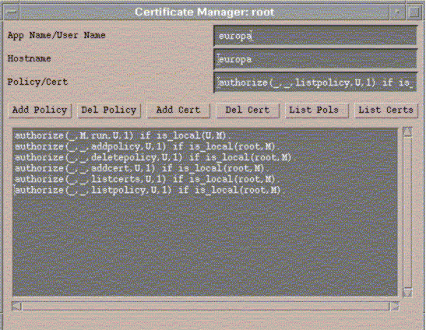

Figure 6. The Certificate Manager Window.

The Certificate Manager has text fields to enter the application or user name, the hostname, and the policy or certificate to be viewed or altered. Buttons are provided to execute the desired command. A text window at the bottom displays the policy or certificate called for.

To show the capability to run multiple applications or instances of an application, SeaBASS has a Clock GUI which is event driven and sends a request to the ClockServer once every second. Figure 7 shows multiple clocks.

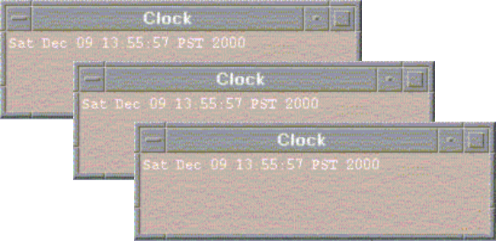

Figure 7. Multiple Clock GUIs.

CBass Applications
Applications that will use the SeaBASS need to implement the CBassInterface. The use of this interface distinguishes CBass applications from other applications. The interface also provides a uniform way for CBass to communicate with its applications. The uniform way is a method called getResource. Any resource application will enter the functionality it needs to be a resource in this method. The method takes a Request object as a parameter. The Request object has an object field that can be used for application specific information.

All CBass applications will need to start a CBass, before they can request resources, or provide resources. Two things must be done to start CBass. First, instantiate CBass with a name and a reference to the object that started it. Second, call the CBass method setUser. SetUser authorizes the user to run the CBass, and sets user information.

RMI
Object
Lookup
via RMI
Method Call
RemoteInterface
Stub
Skel
RemoteObject
(implements RemoteInterface)

Figure 8. Flow diagram of Remote Method Invocation (RMI).

The CBass system communicates using RMI (Remote Method Invocation). RMI provides a simple means of calling remote methods. The only additional information needed to call remote methods with RMI is the name of the remote host. With that information a reference to the remote object can be obtained and its methods used. This reference to the remote object is not the same type as the remote object, but an interface type that the remote object has implemented. The interface inherits from the Remote object, which provides the ability to operate on a remote system. The interface has all of the methods that can be called remotely. When a method is called through this remote interface it calls a stub object. This stub object knows how to communicate over the network. On the remote side a skel object is called that knows how to translate the data stream back into a method call. Finally the method is called on the remote object.

- FILE AND DATABASE STRUCTURES
A Certificate Database (CD) will contain a reference to a CBass Object’s policy file and certificate file to authorize resource allocation and prove identity. These will be simple text files.

4.0 MAJOR INTERNAL DATA STRUCTURES

  - Request
The request object is used to store all the information needed to request a resource.

The request object contains the following structures:
resourceName - string. Holds the name of the service offering the request.
requestString - string. Holds the request information.
rmiName - string. Holds the name registered with rmi to send request to.
hostName - string. Holds the hostname of the machine of the service.
data - object. Holds any generic data the service may require.

  - Cert (Certificate)
The cert object is used to store credentials, policies and templates. The cert object contains the string array cert for certificates.

The cert object contains the following structures:
cert – string. Holds all the certificate information.
valid – string. Verifies certificate.
signature – string. Identifies the certificate creator.
temporary – boolean. Specifies whether an added certificate should be persistent, meaning written to the certificate file.

  - Response
The response object is application specific. CBass views it as a generic java object, but other applications that know exactly what it is can use it as essentially anything.

4.4 Data Usage by Modules
The matrix in Table 1 shows the usage of the data by the modules.

 |  | Data | Names
 |  | Request | Class |  |  |  | Cert
 | resource  Name | Request  String | rmi  Name | host  Name | data | cert | Valid | signature | temporary
Modules
CD |  |  |  |  |  | C,U | C,U | C,U | C,U
CI | U | U | U | U |  | U
CBass | C,U | C,U | C,U | C,U | C | U

Table 1. Internal array usage cross-reference matrix. The codes used are defined as: Blank – no usage of data, I – initializes, U – uses values, C - creates value.

5.0 Module Descriptions

  - CBass

AppRequest
- get templates from the server
- get credentials from the user
- get local credentials
- request resource from the server
- return results yes or no to the requester

getTemplate
Search for the policy that best matches the parameters, and return that policy.

getCred
Return all of the credentials in memory.

request
Passes the Template, Credentials, and Request to CI.Authorize. If the request is accepted, call getResource from the associated resource object. Return the retrieved resource else return an exception.

  - CI

Authorize
- build prolog program, by combining the template and the credentials
- start prolog interpreter and load the program
- build and run the query
- return yes or no depending on whether the request passed

translateToProlog
- search string for “if”
- if found replace it with “:-“ and return string
- else return exception

translateToUserDefined
- find “:-“
- replace with “if”
- return string

  - CD

Constructor
- Check that the policy and cert filenames are valid.
- Save off these names.
- Read policies from policy file and store in the local policies array.
- Read certificates from cert file and store in the local certs array.

  - CM

ActionPerformed
- Check for an appropriate appname and hostname

Adding or deleting policy or adding or deleting certs
- Create a Request object to the specified app and host for the appropriate type of request
- Tell the user if successful or failure

Listing policies or certs
2. Create a Request object to the specified app and host for “listpolicy” or “listcerts”
3. Send all of the received policies/certs to the output box or an error message if an exception occurs.

5.5 CBassInterface

The CBassInteface provides a uniform and generic way for CBass to access resources. Every application that will use CBass must implement this interface.

